

[jorgemontolio@gmail.com](mailto:jorgemontolio@gmail.com)



[www.jorgemontolio.com](http://www.jorgemontolio.com)

**Senior Gameplay Programmer**

**|**

**Jorge Montolio**



[www.linkedin.com/in/jorge-montolio](http://www.linkedin.com/in/jorge-montolio)

**Master’s in Interactive Technology**

SMU Guildhall | 2014-2016

**Dual degree in Computer Engineering and Math,**

Universidad Autónoma de Madrid | 2008-2013

**EDUCATION**

**SKILLS**

Gameplay Programming, Gameplay Design, Systems Design & Scripting, Technical Design,   
Animation Scripting, Animation Systems.

**Game Development**

**Programming / Scripting**

C++, C, 3D Math, Unreal Blueprint.

**Engines and Tools**

Unreal Engine 5, Unreal Engine 4, Unity, Microsoft Visual Studio, Perforce, Subversion.

**LATEST WORK**

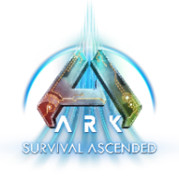

**Senior Gameplay Programmer** (2022 – Present)

**Unreal Engine 5**

Studio Wildcard|*ARK 2,* [*ARK: Survival Ascended*](https://steamcommunity.com/app/2399830)

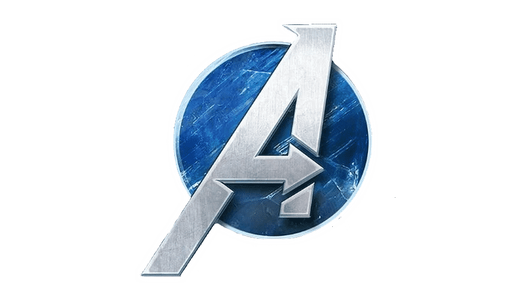

**Player Systems Designer** (2019 – 2021)

Crystal Dynamics|[*Marvel’s Avengers*](https://store.steampowered.com/app/997070/Marvels_Avengers__The_Definitive_Edition/)

**Foundation Engine**

* Created a dynamic animation system which would dynamically select climbing animations for the player to climb dinos of any size, using motion warping.
* Collaborated with a senior animator to completely rework the swimming animation system, and scripted the new swimming animation blueprint.
* Implemented a new camera system in C++ and blueprint, that used spring interpolation and was able to adapt to different creatures’ speeds.
* Worked with level designers and tech artists to create a foliage system in blueprint, which allowed artists to paint foliage on dinosaurs. The foliage would grow over time, and it could be harvested by players.

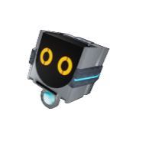

**Lead Level Designer** (2015)

[*Gravitas*](https://store.steampowered.com/app/997070/Marvels_Avengers__The_Definitive_Edition/)

**Unreal Engine 4**

**OTHER WORK**



**GDC Platinum Winner**, Narrative Review Competition

for the [Narrative Review of the game *Braid*](https://www.jorgemontolio.com/blank-1).

[**Master’s Thesis**](https://www.jorgemontolio.com/project-overview) 2015 - 2016

**“***Creating narrative-oriented systems for a Point and Click adventure in Unreal Engine 4”*

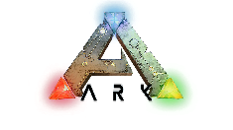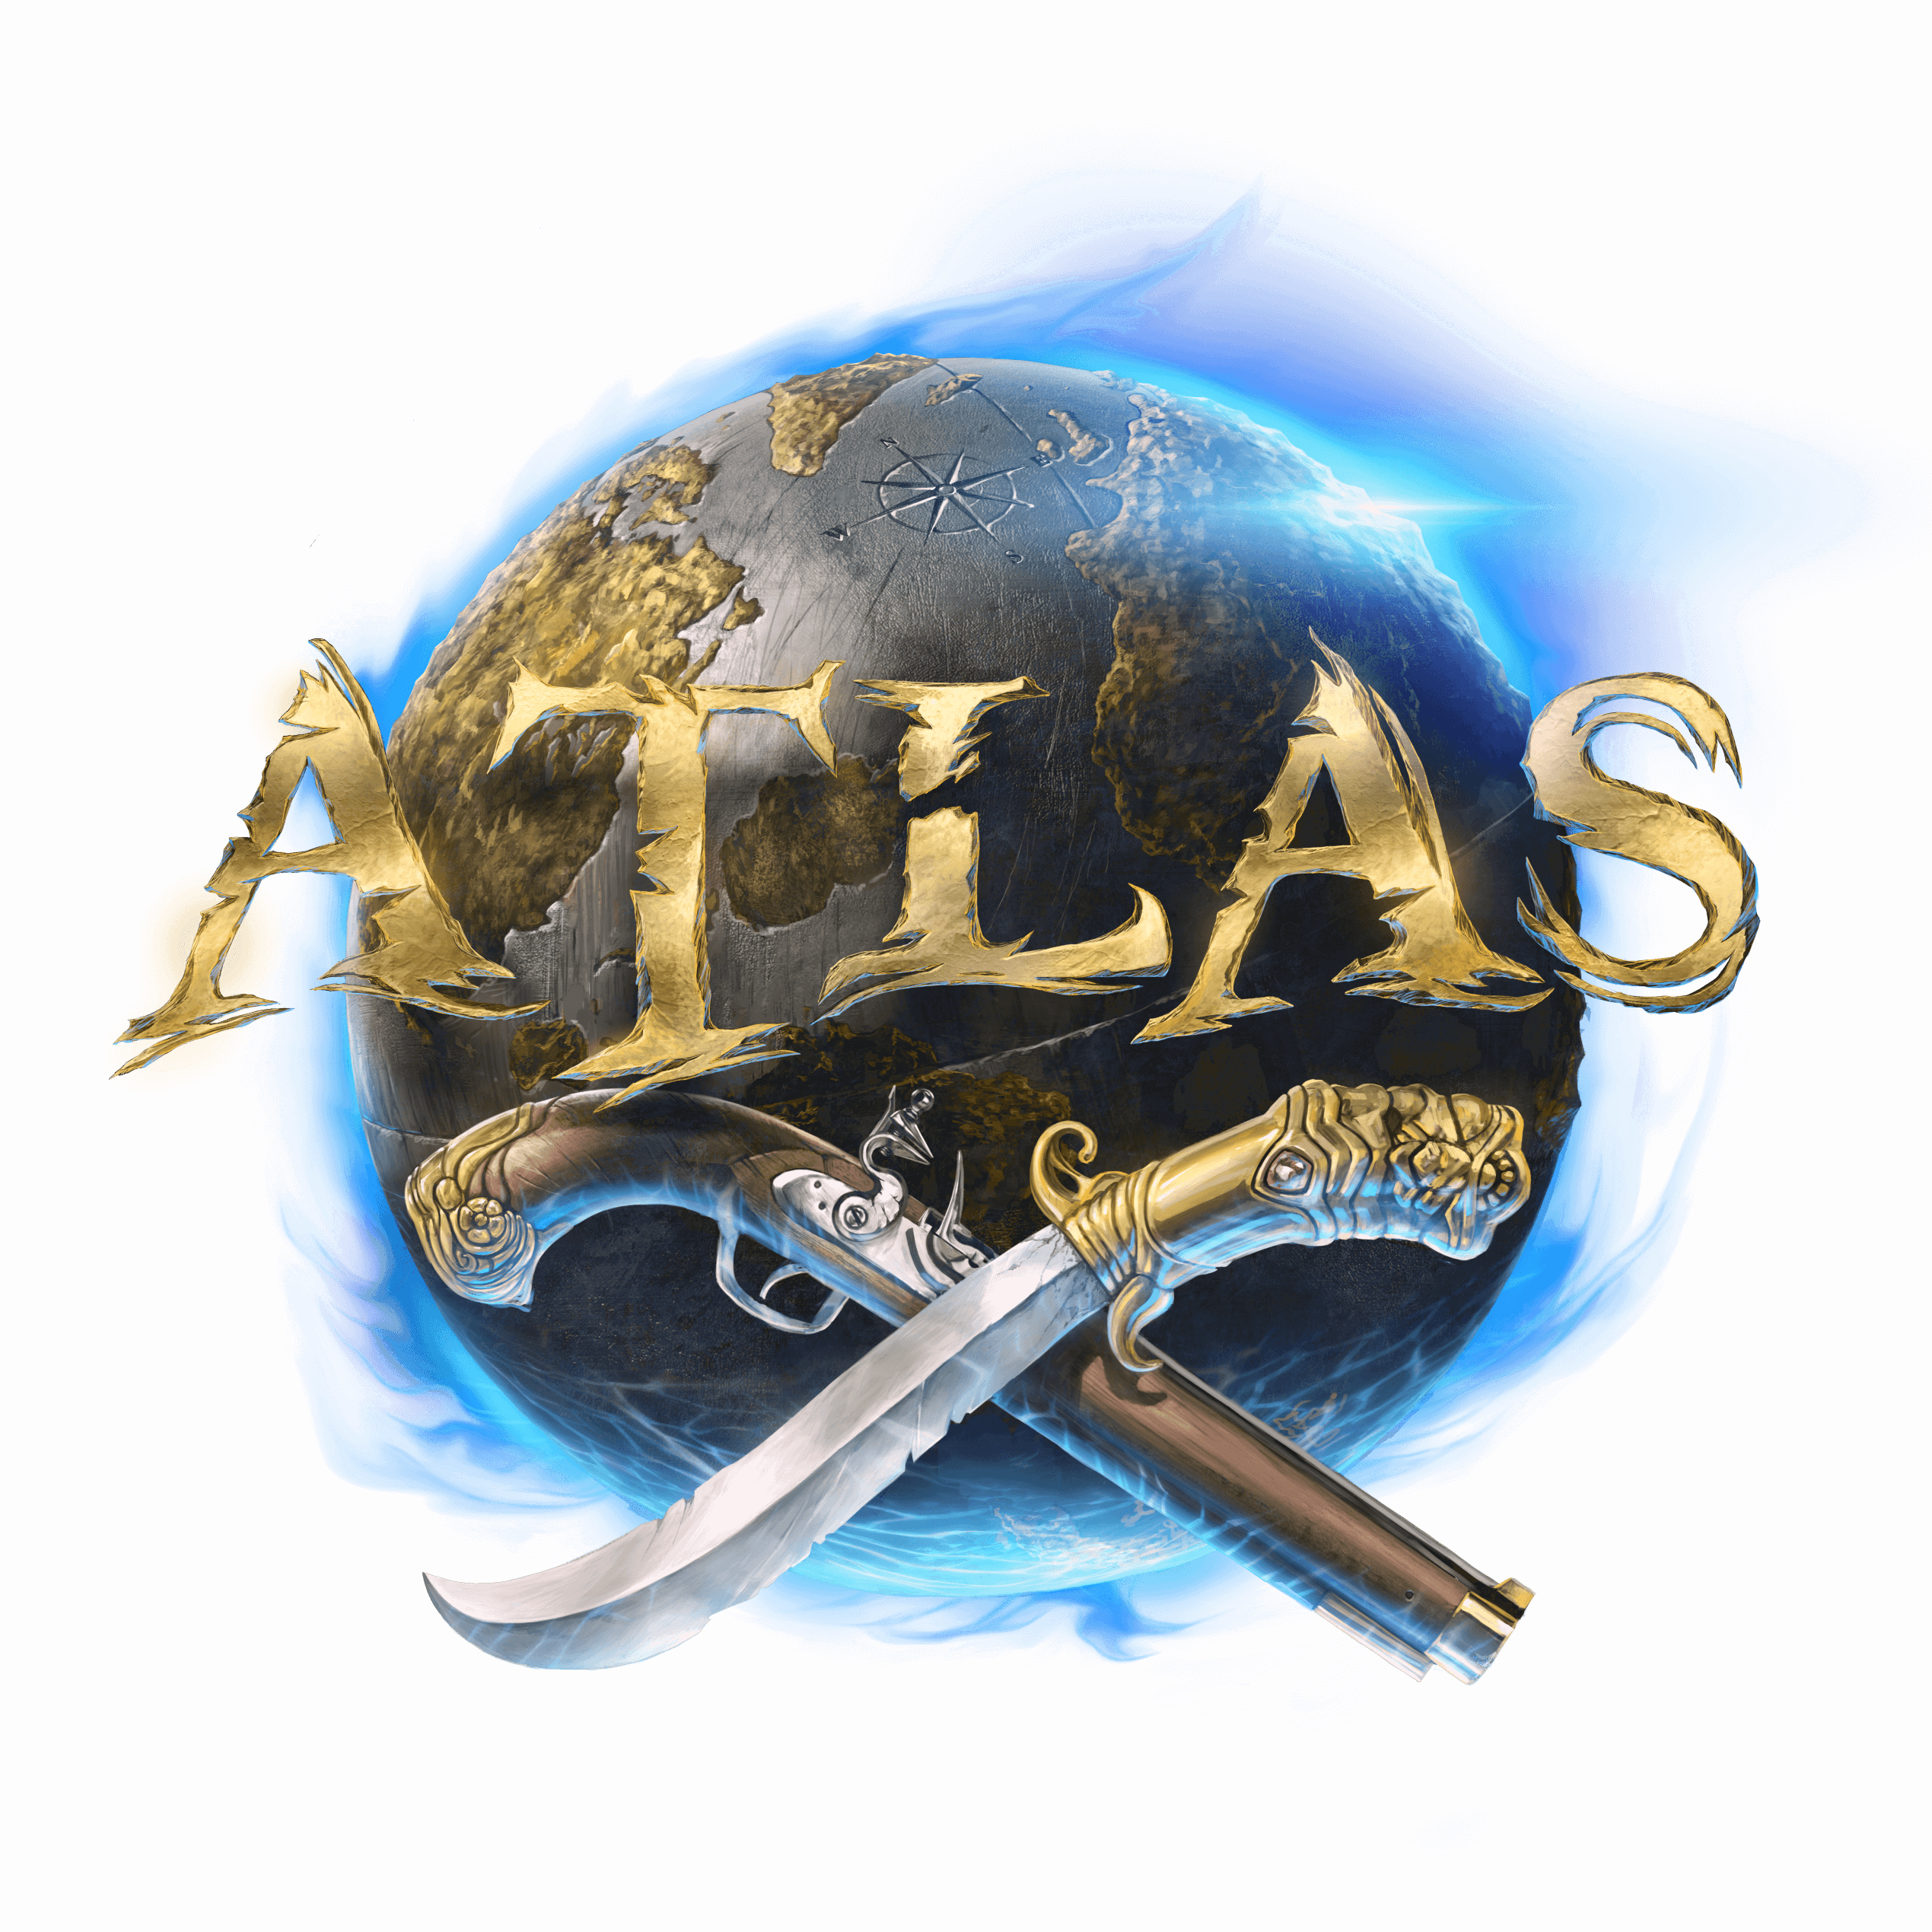

**Gameplay Programmer** (2016 – 2019)

**Unreal Engine 4**

Studio Wildcard| [*ARK: Survival Evolved*](https://store.steampowered.com/app/346110/ARK_Survival_Evolved/)*,*

[*ARK: Scorched Earth*](https://store.steampowered.com/app/512540/ARK_Scorched_Earth__Expansion_Pack/)*,*

[*ARK: Aberration*](https://store.steampowered.com/app/708770/ARK_Aberration__Expansion_Pack/)*,* [*Atlas*](https://store.steampowered.com/app/834910/ATLAS/)

* Led the team’s level design department.
* Organized the game’s steam release, creating the Steam page, marketing the game, making game builds, hiring localization services, and setting up achievements, among others.
* Coordinated all the level designers, assigned tasks, and made sure that all design-related deadlines were met.
* Drove the creative process behind the game’s level design, and made sure that all levels had consistent design and difficulty.
* Designed puzzle areas in more than five of the game levels.
* Collaborated with the programming team to create the main game mechanic: the gravity fields.
* Worked on the skills, combat, and gameplay systems of several of Avenger's heroes.
* Designed and scripted heroes' combat skills, including melee attacks, ranged attacks, and heroic skills.
* Designed and built some of Black Panther's and Spiderman's heroic attacks from scratch.
* Collaborated with level designers and programmers to design and implement the game's revival system.
* Reworked and rebuilt the heroes' defense system.
* Programmed and designed the melee combat system for the multiplayer game *Atlas*, using C++ and Unreal Blueprint.
* Scripted the gameplay of many of *ARK*’s creatures and enemies, using C++ and blueprint.
* Implemented several weapons, including the sword, the mace, the charge lantern, and the dual pistols.
* Modified *ARK’s* animation system to allow the dual wielding of weapons.
* Scripted the Charge system, one of the main gameplay mechanics in *ARK: Aberration.*
* Developed the Ship Captain system in C++, which allows players to control all the cannons and weapons on their ship.
* Collaborated with artists and animators daily, communicating design ideas, technical challenges, and animation requirements for *ARK*’s creatures.